***LANDSLIDE DETECTION SYSTEM***

Vishal Kumar Sah

Department of Computer Science and Engineering

MSRIT

Bangalore,India

Vishalsah7@gmail.com

Rakesh Roshan

Department of Computer Science and Engineering

MSRIT

Bangalore, India

rakeshroshan.raka@gmail.com

Sumeet Sen

Department of Computer Science and Engineering

MSRIT

Bangalore, India Sum1.manunited@gmail.com

Supratik sharma

Department of Computer Science and Engineering

MSRIT

Bangalore, India

supratiksharma@gmail.com

***Abstract*— The internet of things (iot) refers to the ever-growing network of physical objects that feature an ip address for internet connectivity, and the communication that occurs between these objects and other internet-enabled devices and systems, examples of objects that can fall into the scope of internet of things include connected security systems, thermostats, cars, electronic appliances, lights in household and commercial environments, alarm clocks, speaker systems, vending machines and more.  Businesses can leverage iot applications to automate safety tasks (for example, notify authorities when a fire extinguisher in the building is blocked) to performing real-world a/b testing using networked cameras and sensors to detect how customers engage with *products.***

**Landslides cause significant damages to civil infrastructure. Over the years, methods and technologies have been proposed to determine the risk of landslides and to detect hazardous slope movements. There have been increasing interests in developing and landslide monitoring systems to observe movements using sensors installed on the slope. Although providing accurate data, many landslide monitoring systems are not operating in an automated fashion and lack the ability to analyze the collected data in a timely manner.**

**Use of technology in different areas to get various benefits in itself research of big area. Use of vibration sensor in the landslide detection is not a new trend. This is an IOT project to detect landslides by monitoring various sensor’s data real time and uploading the data on cloud in order to alert people in case of any ongoing landslide situation or a probable landslide situation in landslide prone areas. This is a microcontroller based (using Raspberry pi soc) project which is interfaced with various sensors like vibration sensor, moisture sensor, pressure sensor and the soc is configured to connect to an existing cloud framework provided by a free and open source cloud infrastructure ubidots .**

**In this chapter ,the concept of smart landslide detection and storage system is described and use of different advanced technology towards landslide detection sector is highlighted. The evolution of different advanced technology is also presented. Some details about the development of smart landslide detection prototype for irrigation control.**

Keywords: Cloud computing, IOT, Raspberry pi,Vnc ,

Putty,sensor

1. **Introduction**

Environmental disasters are largely unpredictable and occur within very short spans

of time. Therefore technology has to be developed to capture relevant signals with

Minimum monitoring delay. Wireless sensors are one of the cutting edge technologies that can quickly respond to rapid changes of data and send the sensed data to a data analysis

Center in areas where cabling is inappropriate.

Landslides are gravitational movements of soil or rock down slopes that can cause severe damage to civil infrastructure. Numerous fatalities and structural failure caused by landslides have been reported over the years Therefore, efforts to measure and to monitor potential landslides are essential to ensure human safety and to protect civil infrastructure. To observe the behavior of slopes, monitoring systems have been installed or manual inspections by human experts have been conducted. Several measurement techniques have been proposed to identify slope instability and to estimate the risk of landslides For example, map analyses and aerial reconnaissance are used to assess the risk of landslides based on the interpretation of terrain and geological information. These methods, however, are known to be costly and labor-intensive as well as highly subjective because the results depend on the experience and judgment of the human experts. Furthermore, landslide-indicating features in certain terrains (e.g. forests) cannot be identified by these techniques.

This paper presents a preliminary research effort towards the development of an autonomous landslide monitoring system based on wireless sensor networks that is capable to collect and process data autonomously

1. RELATED WORK

Wireless sensor technology has generated enthusiasm in computer scientists to learn and understand other domain areas which have helped them to propose or develop realtime deployments. One of the major areas of focus is environmental monitoring, detection and prediction. The Drought Forecast and Alert System (DFAS) has been proposed and developed in; it uses mobile communication to alert the users, whereas the deployed system uses real time data collection and transmission using the wireless sensor nodes, WiFi, satellite network and also through internet. The real streaming of data through broadband connectivity provides connectivity to wider audience. An experimental soil monitoring network using a WSN is presented in reference [3], which explores real-time measurements at temporal and spatial granularities. Paper [4] describes a state-of-the-art system that combines multiple sensor types to provide measurements to perform deformation monitoring. Reference [5] discusses the topic of slip surface localization in wireless sensor networks, which can be used for landslide prediction. A durable wireless sensor node has been developed [6], which can be employed in expandable wireless sensor networks for remote monitoring of soil conditions in areas conducive to slope stability failures. .

.

1. SENSORS NEEDED FOR MONITORING
2. *Vibration sensor module alarm Motion sensor module vibration switch SW-420*

The Vibration module based on the vibration sensor SW-420 and Comparator LM393 to detect if there is any vibration that beyond the threshold. The threshold can be adjusted by the on-board potentiometer. When this no vibration, this module output logic LOW the signal indicate LED light,And vice versa

1. *DHT11 Temperature and Humidity Sensor*

This DHT11 Temperature & Humidity Sensor features a temperature & humidity sensor complex with a calibrated digital signal output. By using the exclusive digital-signal-acquisition technique and temperature & humidity sensing technology, it ensures high reliability and excellent long-term stability. This sensor includes a resistive-type humidity measurement component and an NTC temperature measurement component, and connects to a high-performance 8-bit microcontroller, offering excellent quality, fast response, anti-interference ability and cost-effectiveness.

1. ARCHITECTURE DESIGN

We use sensors ie. Vibration sensor, humidity sensor and the data from each of the sensors is uploaded to the cloud in real time via raspberry pi soc.

The sensors are interfaced with the soc where the analog signal collected by the sensors is converted into digitally interpretable data. This digital data is the output from the sensors which act as an input for the raspberry pi board.

The board sends this data to the ubidots cloud. Our board is configured to connect to the ubidots cloud using the proprietary software provided by ubidots which runs on the Raspian OS installed on the raspberry pi soc.

This project has three sensor as its component. Raspberry pi[9] is being used to read data from sensor and for the implementation of the project. The concept of storing data using cloud platform is being used to store data of sensor from cloud and send the data to email[9] so that it could be analysed and used by the user.

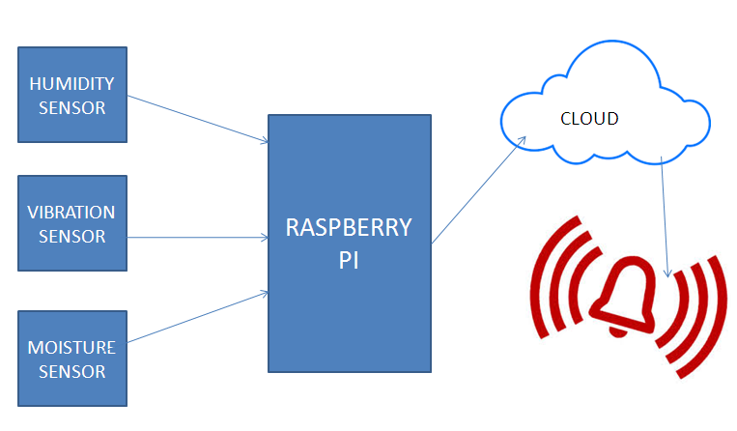

Fig.1 architecture overview diagram

The Dth11 send temperature and humidity sensor to the raspberry pi..The motion detector detect the presence of the human being and send data, which is further send to cloud and after analysing the data, user is being notified if it is necessary.

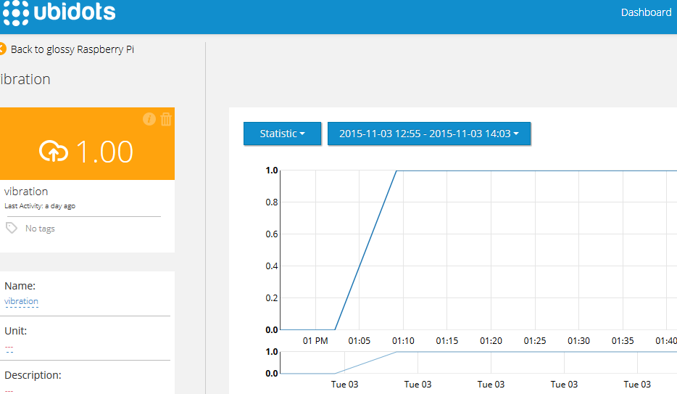

Fig 2. dashboard to monitor data

1. IMPLEMENTATION
2. *Code to connect to cloud server and send it*

import RPi.GPIO as GPIO

import dht11

import time

from ubidots import ApiClient

# initialize GPIO

GPIO.setwarnings(False)

GPIO.setmode(GPIO.BOARD)

GPIO.cleanup()

GPIO.setup(19,GPIO.IN)

GPIO.setup(7,GPIO.IN)

GPIO.setup(8,GPIO.IN)

#Create an "API" object

api = ApiClient("f0aee71e9c7d1ca8e792c1b39cb90448d734d76c")

#Create a "Variable" object

test_variable = api.get_variable("5669177d76254278e8150f21")

test1_variable = api.get_variable("56695d66762542112ed97c2b")

test2_variable = api.get_variable("56695d56762542128eb5dbfb")

test3_variable = api.get_variable("566973c876254243f3602899")

# read data using pin 14

instance = dht11.DHT11(pin = 8)

result = instance.read()

result1= GPIO.input(19)

time.sleep(0.1)

current_state = GPIO.input(7)

if result.is_valid():

test_variable.save_value({'value':result.temperature})

test2_variable.save_value({'value':result.humidity})

test1_variable.save_value({'value':result1})

test3_variable.save_value({'value':current_state})

else:

print("Error: %d" % result.error_code)

1. *Code library for the functioning of DHT*

*sensor dth11[10]*

import time

import RPi.GPIO as GPIO

class DHT11Result:

DHT11 sensor result returned by DHT11.read() method'

ERR_NO_ERROR = 0

ERR_MISSING_DATA = 1

ERR_CRC = 2

error_code = ERR_NO_ERROR

temperature = -1

humidity = -1

class DHT11:

'DHT11 sensor reader class for Raspberry'

__pin = 0

def __init__(self, pin):

def read(self):

GPIO.setup(self.__pin, GPIO.OUT)

self.__send_and_sleep(GPIO.HIGH, 0.05)

self.__send_and_sleep(GPIO.LOW, 0.02)

GPIO.setup(self.__pin, GPIO.IN, GPIO.PUD_UP)

data = self.__collect_input()

pull_up_lengths self.__parse_data_pull_up_lengths(data)

if len(pull_up_lengths) != 40:

return DHT11Result(DHT11Result.ERR_MISSING_DATA, 0, 0)

bits = self.__calculate_bits(pull_up_lengths)

the_bytes = self.__bits_to_bytes(bits)

checksum = self.__calculate_checksum(the_bytes)

if the_bytes[4] != checksum:

return DHT11Result(DHT11Result.ERR_CRC, 0, 0)

return DHT11Result(DHT11Result.ERR_NO_ERROR, the_bytes[2], the_bytes[0])

unchanged_count = 0

max_unchanged_count = 100

last = -1

data = []

while True:

current = GPIO.input(self.__pin)

data.append(current)

if last != current:

unchanged_count = 0

last = current

else:

unchanged_count += 1

if unchanged_count > max_unchanged_count:

break

return data

lengths = []

current_length = 0

for i in range(len(data)):

current = data[i]

current_length += 1

if state == STATE_INIT_PULL_DOWN:

if current == GPIO.LOW:

state = STATE_INIT_PULL_UP

continue

else:

continue

for i in range(0, len(pull_up_lengths)):

length = pull_up_lengths[i]

if length < shortest_pull_up:

shortest_pull_up = length

if length > longest_pull_up:

longest_pull_up = length

halfway = shortest_pull_up + (longest_pull_up - shortest_pull_up) / 2

bits = []

for i in range(0, len(pull_up_lengths)):

bit = False

if pull_up_lengths[i] > halfway:

bit = True

bits.append(bit)

return bits

for i in range(0, len(bits)):

byte = byte << 1

if (bits[i])

byte = byte | 1

else:

byte = byte | 0

if ((i + 1) % 8 == 0):

the_bytes.append(byte)

byte = 0

return the_bytes

1. CONCLUSION AND FUTURE WORK

Real time monitoring of landslides is one of the

challenging research areas available today in the field of geophysical research. This paper discusses the development of an actual field deployment of a wireless sensor network based landslide detection system. This system uses a heterogeneous network composed of wireless sensor nodes, Wi-Fi, and satellite terminals for efficient delivery of real time data to the data management center, to enable

sophisticated analysis of the data and to provide landslide warnings and risk assessments to the inhabitants of the region. This network will be used for understanding the capability and usability of wireless sensor network for critical and emergency application.

We concluded that how using technology could solve the real life problem of the people in much efficient and better way. How technology has made the life of human being so easy and how it could eliminate problem of the people, society and any other organization. So such an idea could change the scenario of the society and the people and it has become integral part of the human world.

1. ACKNOWLEDEMENT

We cordially thank our respected HOD Sir,Dr. K. G. Srinivasa for assisting us in presenting this paper and giving us the opportunity to work on some real life problem..We thank our department faculty who provided insight and expertise that greatly assisted and motivated us.

We would also like to show our gratitude to our respected teacher Dr.Anita Kanavalli,  Mrs.Sowmya B. J for sharing their pearls of wisdom with us during the course of this project work.

We are also immensely grateful to our family without whose blessing it could not had been possible.

**REFERENCE**

[1].https://www.researchgate.net/publication/221933039_Real-Time_Wireless_Sensor_Network_for_Landslide_Detection

[2].http://www.webopedia.com/TERM/I/internet_of_things.html

[3]. <https://en.wikipedia.org/wiki/vibration> sensor

[4].https://www.sparkfun.com/products/13322

[5].http://searchcloudcomputing.techtarget.com/definition/cloud-computing

[6].http://www.engineersgarage.com/articles/humidity-sensor

[7].http://www.electronics-tutorials.ws/io/io_3.html

[8].https://www.raspberrypi.org

[9].https://www.google.co.in/#q=email

[10].<http://www.instructables.com/id/How-to-interface-Humidity-and-Temperature-DTH11-Se>

[11].http://searchcloudcomputing.techtarget.com/definition/cloud-computing